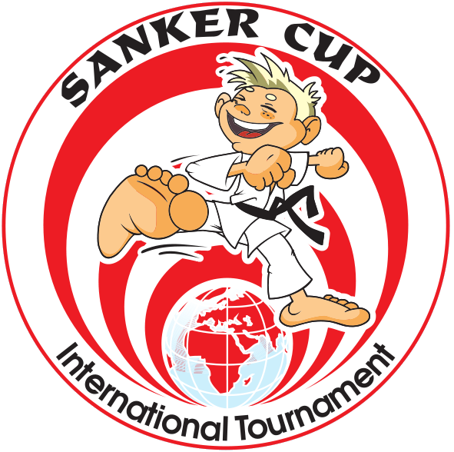
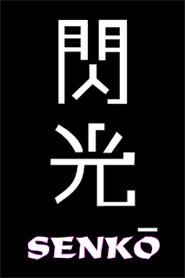
Demand for participation at fifth international karate tournament
«MINSK OPEN - SANKER CUP» 2009
October 2-4 2009, Minsk, Belarus
111, Kalinovskogo street, Olympic sport complex

Organization: organization name
Address: organization address
Coach: Coaches names

Phone/Fax: organization phone/fax
e-mail: enter email
City: enter the city
Country: enter the country

¹ | Surname and First Name | Date of birth | Age | Kumite |  | Kata
 |  |  |  | Ind. | Team | Kata
0 | Surname Name (sample) | 25/04/1970 | 39 | Х | - | Х

